ACTIVITY 1.34

**Q1. Write a python program to sort a list of ‘n’ integers using insertion sorting. Print the list of numbers Before and After sorting.**

**#code screenshot**

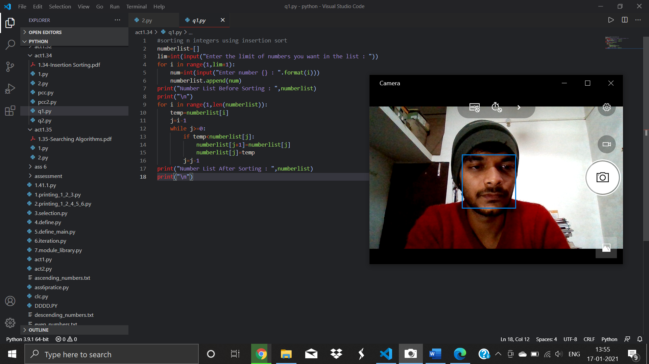

**#code**

#sorting n integers using insertion sort

numberlist=[]

lim=int(input("Enter the limit of numbers you want in the list : "))

for i in range(1,lim+1):

    num=int(input("Enter number {} : ".format(i)))

    numberlist.append(num)

print("Number List Before Sorting : ",numberlist)

print("\n")

for i in range(1,len(numberlist)):

    temp=numberlist[i]

    j=i-1

    while j>=0:

        if temp<numberlist[j]:

            numberlist[j+1]=numberlist[j]

            numberlist[j]=temp

        j=j-1

print("Number List After Sorting : ",numberlist)

print("\n")

**#output screenshot**

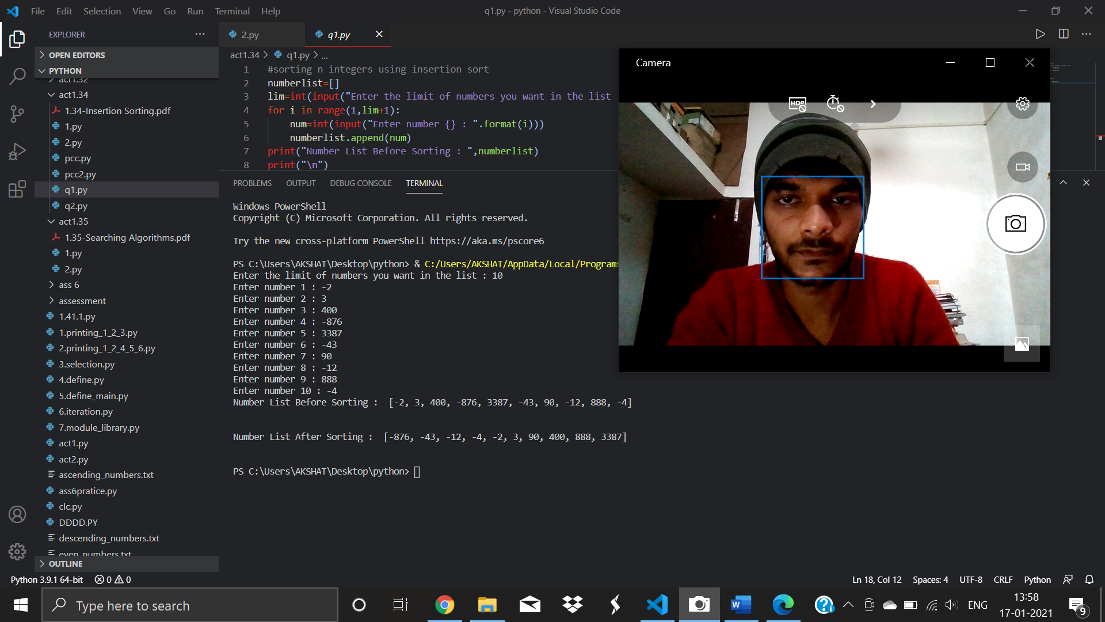

**Q2. Write a python program for the following requirements.**

**a) Read your name using input () and store it in a string variable (say my_name).**

**b) Print my_name on the screen.**

**c) Using insertion sorting technique, sort the characters in my_name and print them in ascending order.**

**d) Select only the vowel characters from my_name and store them into a file (say ‘vowel_characters.txt’). If your name does not contain any vowel character, then store ‘NO VOWELS IN MY NAME’ into ‘vowel_characters.txt’.**

**e) Trace the program manually (handwritten material) in neat format to show the status of all variables and condition checking for “first five characters of your name”. Add the scanned soft copy into the answer sheet (PDF file).**

**#code screenshot**

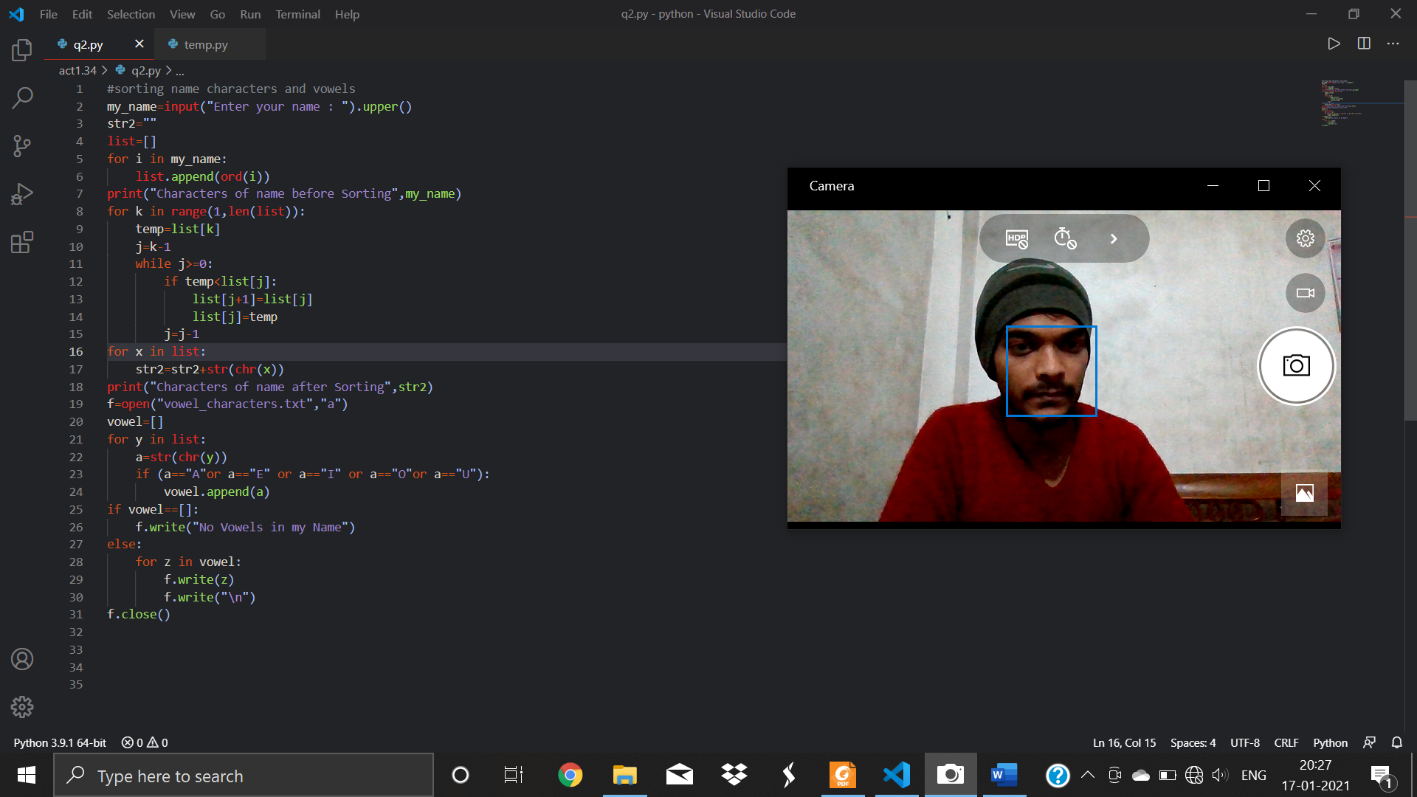

**#code**

#sorting name characters and vowels

my_name=input("Enter your name : ").upper()

str2=""

list=[]

for i in my_name:

    list.append(ord(i))

print("Characters of name before Sorting",my_name)

for k in range(1,len(list)):

    temp=list[k]

    j=k-1

    while j>=0:

        if temp<list[j]:

            list[j+1]=list[j]

            list[j]=temp

        j=j-1

for x in list:

    str2=str2+str(chr(x))

print("Characters of name after Sorting",str2)

f=open("vowel_characters.txt","a")

vowel=[]

for y in list:

    a=str(chr(y))

    if (a=="A"or a=="E" or a=="I" or a=="O"or a=="U"):

        vowel.append(a)

if vowel==[]:

    f.write("No Vowels in my Name")

else:

    for z in vowel:

        f.write(z)

        f.write("\n")

f.close()

**#output screenshot**

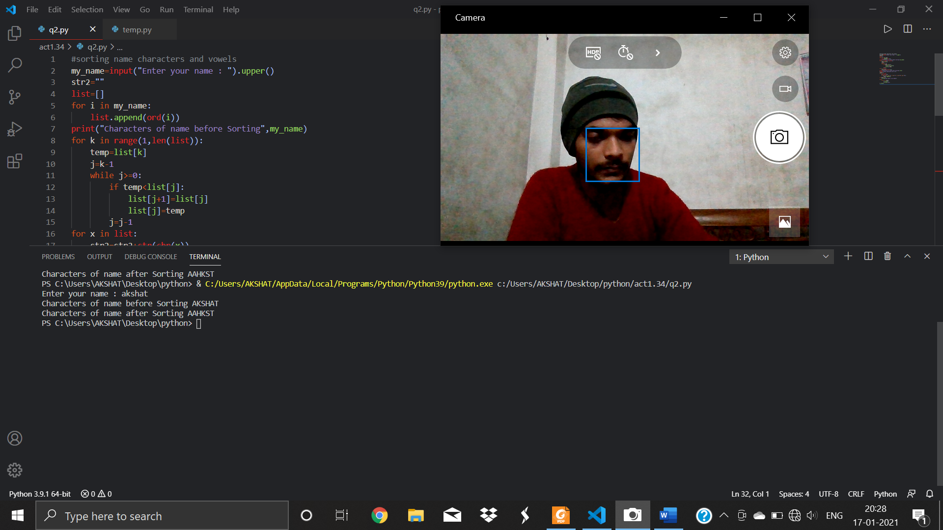

**#file created**

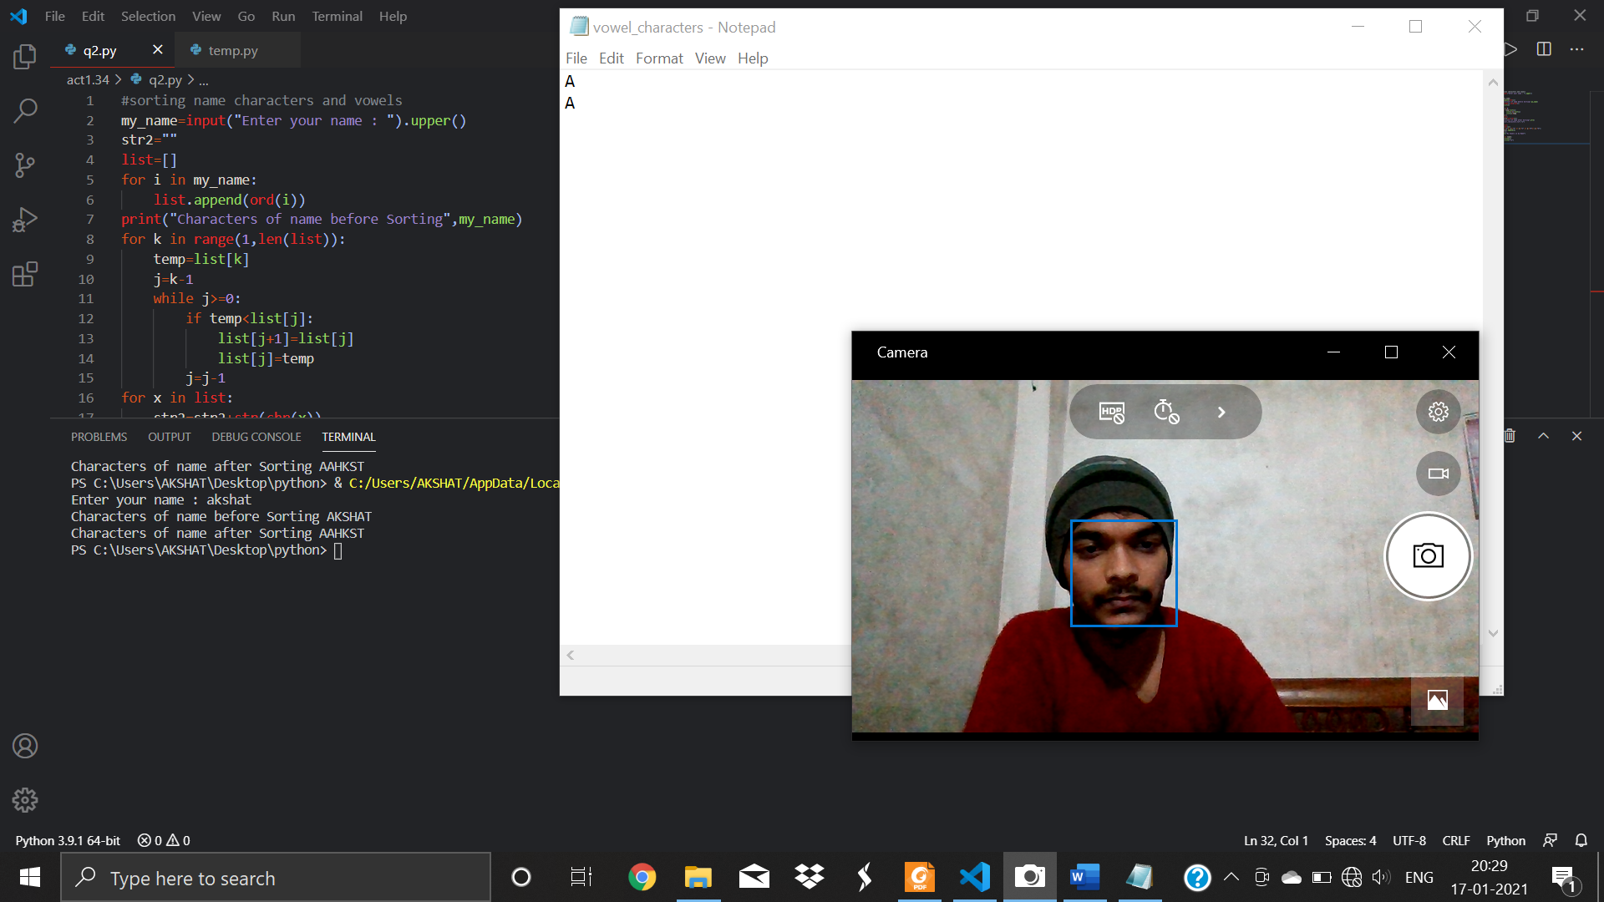

**#tracing**

***